Cairo University  
Faculty of Computers and Information



**CS251**

**Software Engineering I**

Android Theft Monitoring App

Software Requirements Specifications

Team Names

Team A

Month & Year

November 2016

Contents

Instructions [To be removed] 2

Team 3

Document Purpose and Audience 3

Introduction 3

Software Purpose 3

Software Scope 3

Definitions, acronyms, and abbreviations 3

Requirements 4

Functional Requirements 4

Non Functional Requirements 4

System Models 4

Use Case Model 4

Use Case Tables 5

Ownership Report 6

# Instructions [To be removed]

* **IMPORTANT. Rename this document to CS251-LeaderID-SRSDocument.docx**

**(e.g. CS251-20040752-SRSDocument.docx)**

* **Remove the following notes and any red notes.**
* **This document is the template document for your SRS.**

# Team

|  |  |  |  |
| --- | --- | --- | --- |
| **ID** | **Name** | **Email** | **Mobile** |
| 20146001 | Ahmed Samir |  |  |
| 20146017 | Habiba Bahaa |  |  |
| 20146004 | Ahmed Mustafa |  |  |
| 20146005 | Alaa Sameh |  |  |
| 20146003 | Ahmed Mohammed |  |  |
| 20146008 | Sara Sedky |  |  |

# 

# Document Purpose and Audience

# Software requirements specifications is a document that describes the expected behavior of “Theft Monitoring” Application such that functional requirements , non-functional requirements , use case model , use case tables are identified in this document.

# Target Audience are project owner and the customer

# Introduction

## Software Purpose

* **The software purpose is to provide the ability of returning the stolen mobile easily through an application that sends a message to a pre - defined number saved , This message contains the location of the mobile and other info about the mobile and its data.**

## Software Scope

* **Allow user to enter his info, sign up (mobile number and name ) by using a web interface.**
* **Get the location of the mobile every part of time**
* **Get the list of contacts**
* **Format the mobile storage**
* **Launch camera and take a photo**
* **record audio track for a certain part of time**
* **Get the list of calls made by the thief**
* **Get number and serial of the new inserted sim card**

## 

## Definitions, acronyms, and abbreviations

* **None**

# 

# Requirements

## Functional Requirements

* It is a mobile application that displays the mobile’s current location when stolen or lost. Mobile app uses GPS satellites (global positioning system) to determine its location and send the location to the predefined number or email.
* When the mobile phone gets stolen, the GPS automatically locate the stolen phone and sends the mobile’s current location to the predefined number or email.

* As the application is running it sends a message with all the current contacts on the mobile phone to the predefined number or email so that the user can ensure the availability of his contact list even if the mobile phone get formatted.
* As the application is running it will request the front camera to launch and take several pictures of the thief without him knowing and send it to the predefined number and email
* As the application is running it will request the voice recorder to launch and record several audios for the thief and send them to the predefined number or email

* When a new SIM card is inserted and the application runs, the serial number is sent to the predefined number and email

## 

## Non Functional Requirements

1) **Usability:**

* User must have an account to access the devices.
* User must be setup the Application on the Setting on phone
* Phone connected be default ( when phone turned on )
* On startup a use guide will load to go through the whole system and how it could be used

2) **Reliability:**

* In case of application crash, none of the other applications or the OS will be affected.
* In case of system failure when user turned off and turned on again and restart the Application
* Application won't remove or uninstalled if phone is shut down

3) **Performance:**

* In case of lost connection with device, application will try to reconnect automatically every 20 seconds for 3 times and then it will be disconnected if the user did not manually click retry.
* When startup the phone the Application send photo of the place where phone is and taken no more 2min form starting phone
* Application send message has list of contacts how phone calls after one hour after starting a phone

4) **Security:**

* Only users registered can have access to the devices connected to their board.
* Access differs depending on the type of user whether an Admin or a Phone User

**5) Scalability:**

* System will support all phone appliances with GPS
* System will support Android mobile application
* System should handle smoothly up to 6 devices.

# System Models

## Use Case Model

## 

## C:\Users\DELL\AppData\Local\Microsoft\Windows\INetCache\Content.Word\UseCaseDiagram1.jpg

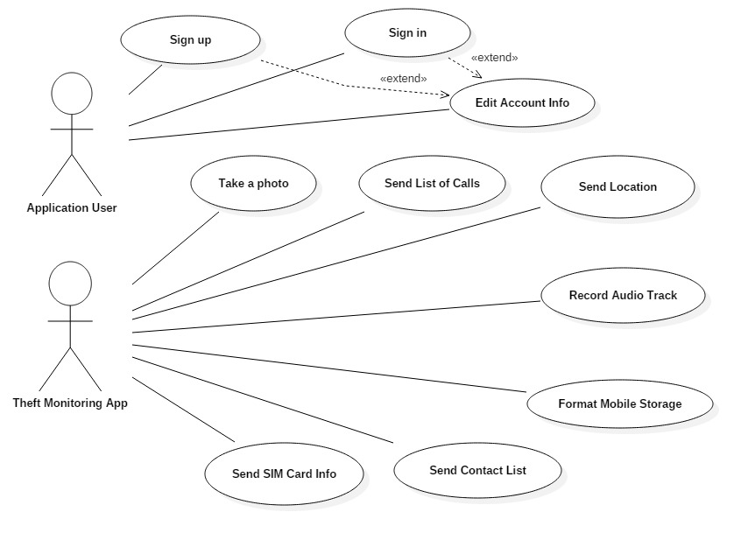

|  |  |  |
| --- | --- | --- |
| Use Case ID: | 17 | |
| Use Case Name: | Get Location | |
| Actors: | Thief - Android Monitoring Theft application (dispatcher) | |
| Pre-conditions: | New SIM Card is inserted | |
| Post-conditions: | Location of the lost mobile is identified and sent | |
| Flow of events: | **Thief Action** | **System Action** |
| 1- User inserts new SIM Card |  |
|  | 2 – Application starts |
|  | 3 – Application opens the internet and enables GPS |
|  | 4- Application sends mobile’s location to a pre-defined mobile phone number |
|  | 5 – Application closes the internet and disable GPS  6 – Application resets a timer so as to update mobile’s location every defined period of time |
| Exceptions: | **Thief Action** | **System Action** |
| 1 – New SIM card is inserted but no internet connection exists |
|  | 2 – Application sets a timer to check for the internet connection every period of time  3 – Once connected to internet , it starts to function |
| Includes: | None | |

|  |  |  |
| --- | --- | --- |
| Use Case ID: | 18 | |
| Use Case Name: | Get SIM card Info | |
| Actors: | Thief - Android Monitoring Theft application (dispatcher) | |
| Pre-conditions: | New SIM Card is inserted | |
| Post-conditions: | Info of the new inserted SIM Card is identified and sent | |
| Flow of events: | **Thief Action** | **System Action** |
| 1- User inserts new SIM Card |  |
|  | 2 – Application starts and connects to internet |
|  | 3 – Application gets SIM card info stored on the mobile |
|  | 4- Application sends SIM card info to a pre-defined mobile phone number |
|  | 5 – Application closes the internet |
| Exceptions: | **Thief Action** | **System Action** |
| 1 – New SIM card is inserted but no internet connection exists |
|  | 2 – Application sets a timer to check for the internet connection every period of time  3 – Once connected to internet , it starts to function |
| Includes: | None | |
| Notes and Issues: | None | |

|  |  |  |
| --- | --- | --- |
| Use Case ID: | 44 | |
| Use Case Name: | Sign in | |
| Actors: | User | |
| Pre-conditions: | User open the application | |
| Post-conditions: | User sign in the application with his account | |
| Flow of events: | **User Action** | **System Action** |
| 1- User enter username and Password. |  |
|  | 2- System Verify user data |
|  |  |
|  |  |
| Exceptions: | **User Action** | **System Action** |
| 1- User Enter Card and Password. |  |
|  | 2- username or Password is invalid  3- System rejects user. |
| Includes: |  | |
| Notes and Issues: |  | |

|  |  |  |
| --- | --- | --- |
| Use Case ID: | 8 | |
| Use Case Name: | Sign up | |
| Actors: | User | |
| Pre-conditions: | User starts App | |
| Post-conditions: | User Sign up for the app successfully | |
| Flow of events: | **User Action** | **System Action** |
| 1-User Enter name and phone number and other details |  |
|  | 2- System verify data. |
| 3- User sign up successfully |  |
| Exceptions: | **User Action** | **System Action** |
| 1- User Enter name and phone number and other details |  |
|  | 2- System verify data.  3- System rejects entry. |
| Includes: |  | |
| Notes and Issues: |  | |

|  |  |  |
| --- | --- | --- |
| Use Case ID: | 3 | |
| Use Case Name: | Format the mobile | |
| Actors: | Admin-User | |
| Pre-conditions: | User Launches application | |
| Post-conditions: | User successfully remove all memory  User exits the application | |
| Flow of events: | **User Action** | **System Action** |
| 1. Phone will be turned on |  |
|  | 2- System checks if the information is valid |
|  | 3- System checks to connect to data base to can remove the data form memory |
|  | 4- remove all data of memory |
| Exceptions: | **User Action** | **System Action** |
| 1- remove the Application form phone |  |
|  | 2-remove valid information |
|  |  | 3-system fails to save backup and remove it |

|  |  |  |
| --- | --- | --- |
| Use Case ID: | 2 | |
| Use Case Name: | Get the list of contacts | |
| Actors: | Android Theft Monitoring(mobile application) | |
| Pre-conditions: | New sim card installed | |
| Post-conditions: | User get list of contacts | |
| Flow of events: | **User Action** | **System Action** |
| 1- user sim card will be removed and new sim card installed |  |
|  | 2- sending list of contacts to predefined number or email. |
|  |  |
| Exceptions: | **User Action** | **System Action** |
| 1- thief doesn’t remove sim card. |  |
|  | 2- list of contacts corrupted. |
| Includes: |  | |
| Notes and Issues: |  | |

|  |  |  |
| --- | --- | --- |
| Use Case ID: | 6 | |
| Use Case Name: | Get the list of calls made by the thief | |
| Actors: | Android Theft Monitoring | |
| Pre-conditions: | The Thief started making phone calls | |
| Post-conditions: | User get list of calls made by the thief | |
| Flow of events: | **User Action** | **System Action** |
| 1- user sim card will be removed and new sim card installed |  |
|  | 2- - sending list of calls made by the thief to predefined number or email. |
|  |  |
| Exceptions: | **User Action** | **System Action** |
| 1-the thief delete phone calls |  |
|  | 2-the thief doesn’t make any call |
| Includes: |  | |
| Notes and Issues: |  | |

|  |  |  |
| --- | --- | --- |
| Use Case ID: | 111 | |
| Use Case Name: | Edit account info | |
| Actors: | user | |
| Pre-conditions: | User open the application | |
| Post-conditions: | User changed his account information | |
| Flow of events: | **User Action** | **System Action** |
| 1- User click on edit account |  |
|  | 2- System View to user editing page |
| 3- User change his username or password or his primary or secondary number and click on apply. |  |
|  | 4- System respond to user that his account updated |
|  |  |
| Exceptions: | **User Action** | **System Action** |
|  |  |
|  |  |
| Includes: |  | |
| Notes and Issues: |  | |

|  |  |
| --- | --- |
| Use case id |  |
| Use case name | Launch the camera |
| actors | Mobile application |
| Pre conditions | New sim card installed |
| Post conditions |  |
| Flow of events | User action system action   |  |  | | --- | --- | | 1. New sim card installed |  | | 2.request to open camera |  | |  | 3.launch front camera | |  | 4. Capture several pictures | |  | 5. Send the pictures to the predefined number and/or email | |
| exceptions | User action system action   |  |  | | --- | --- | | 1.thief does not remove the sim card |  | |  | 2.camera does not work | |

|  |  |
| --- | --- |
| Use case id |  |
| Use case name | Record audio tracks |
| actors | Mobile application |
| Pre conditions | New sim card installed |
| Post conditions |  |
| Flow of events | User action system action   |  |  | | --- | --- | | 1. New sim card installed |  | | 2.request to open mic |  | |  | 3.launch micc | |  | 4.record several records | |  | 5. Send the voice records to the predefined number and/or email | |
| exceptions | User action system action   |  |  | | --- | --- | | 1.thief does not remove the sim card |  | |  | 2.mic does not work | |